**PROJECT REPORT**

**A COMPREHENSIVE ANALYSIS OF FINANCIAL PERFORMANCE: INSIGHTS FROM A LEADING BANKS**

**ST. JOHN’S COLLEGE**

**PALAYAMKOTTAI**

DEPARTMENT OF PHYSICS

**TEAM MEMBERS:**

**GRACELIN**

**JENIFA**

**JENSEENA SMILINE IDA**

# KABIL DEV

A COMPREHENSIVE ANALYSIS OF FINANCIAL PERFORMANCES- INSIGHTS OF LEADING BANKS

**Introduction:**

**Project description:**

The banking industry world-wide is being transformed. A Comprehensive analysis of financial performance is a detailed investigation based on the assets of the leading banks. The Goal of financial performance is changing in the deregulation of financial services at the national level. Technological innovation leads to the Opening – up to international competition. we are trying to analysis the bank related data and able to extract some insights from the data using Business Intelligence tools.

OVERVIEW:

The data has been collected; it is analyzed through tableau to identify the assets of the leading banks. It describes the risk and return trade-off underlying management decisions. Data are provided that compare the performance characteristics of small banks versus large banks and differentiate between high and low performers.

PURPOSE:

  The purpose of financial performances is used to evaluate economic trends, set financial policies, build long-term plans for business activity, and identify projects or companies for investment.

Problem Definition& Design Thinking:

EMPATHY MAP:

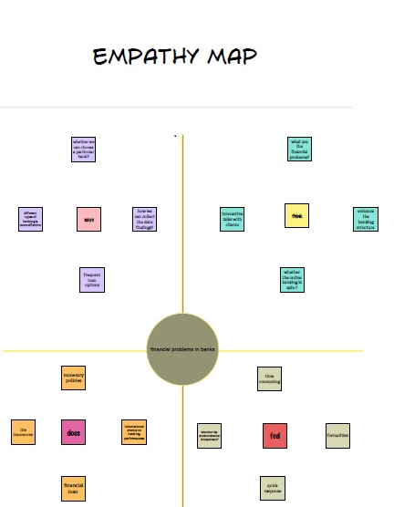

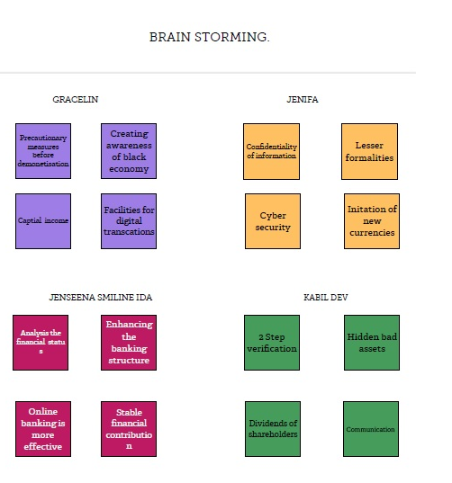

RESULT:

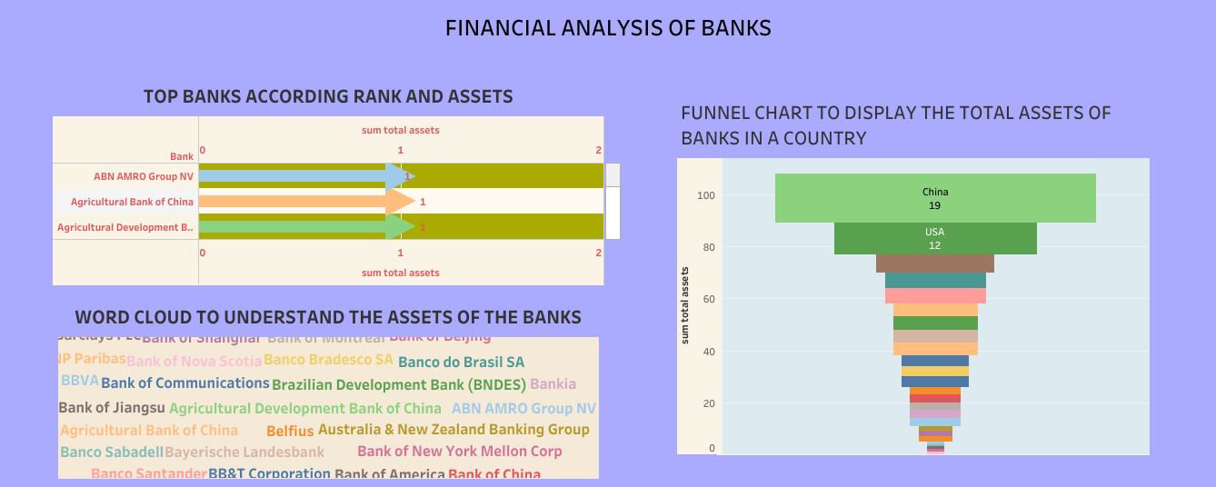

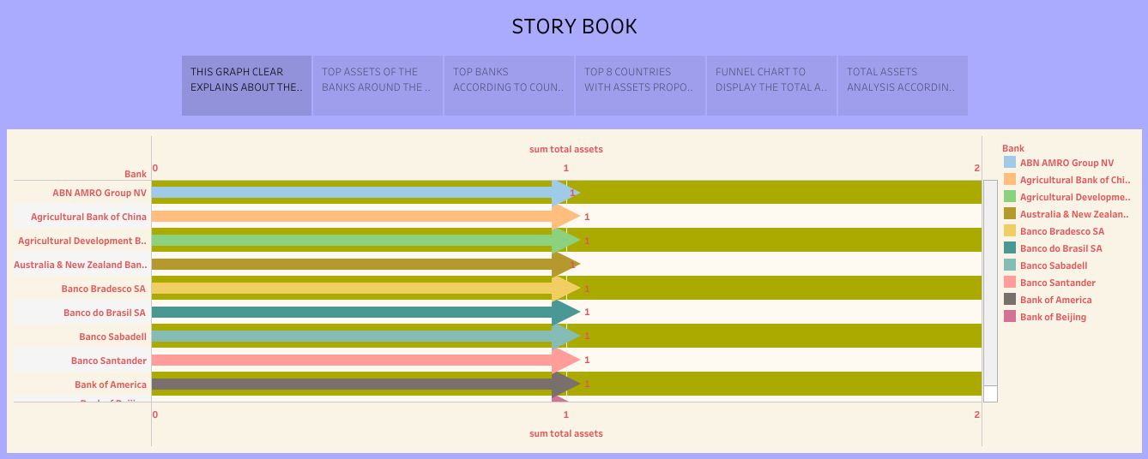

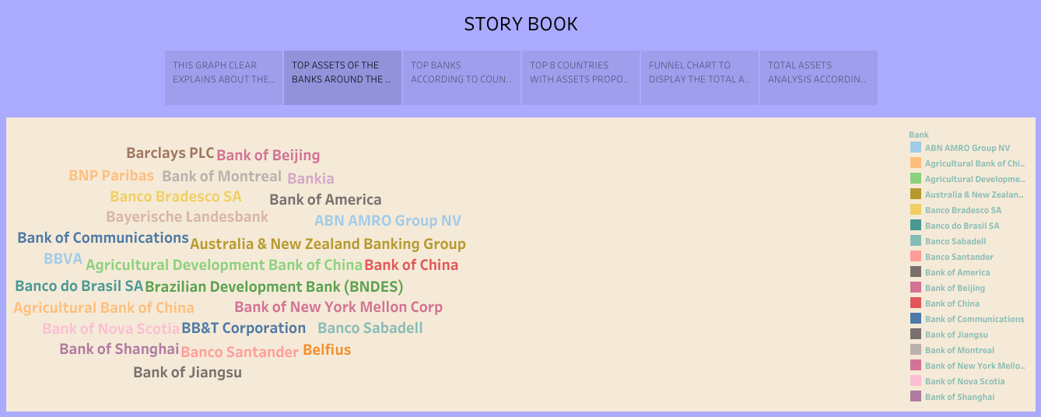

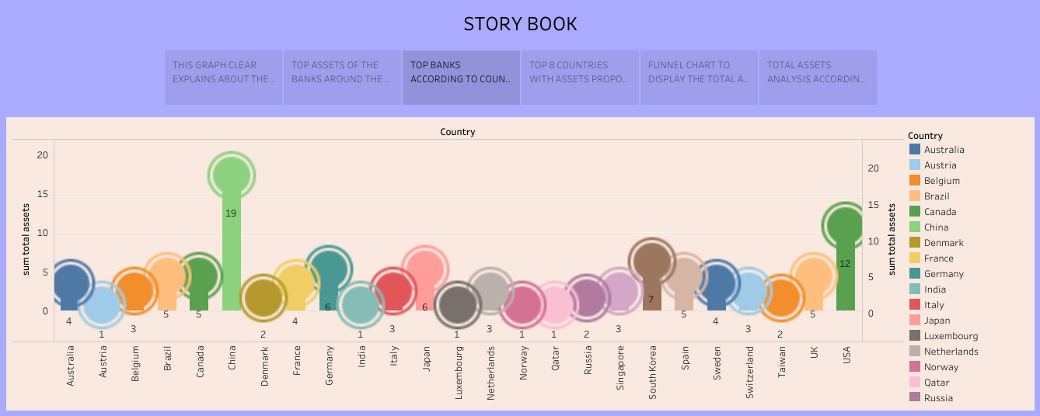

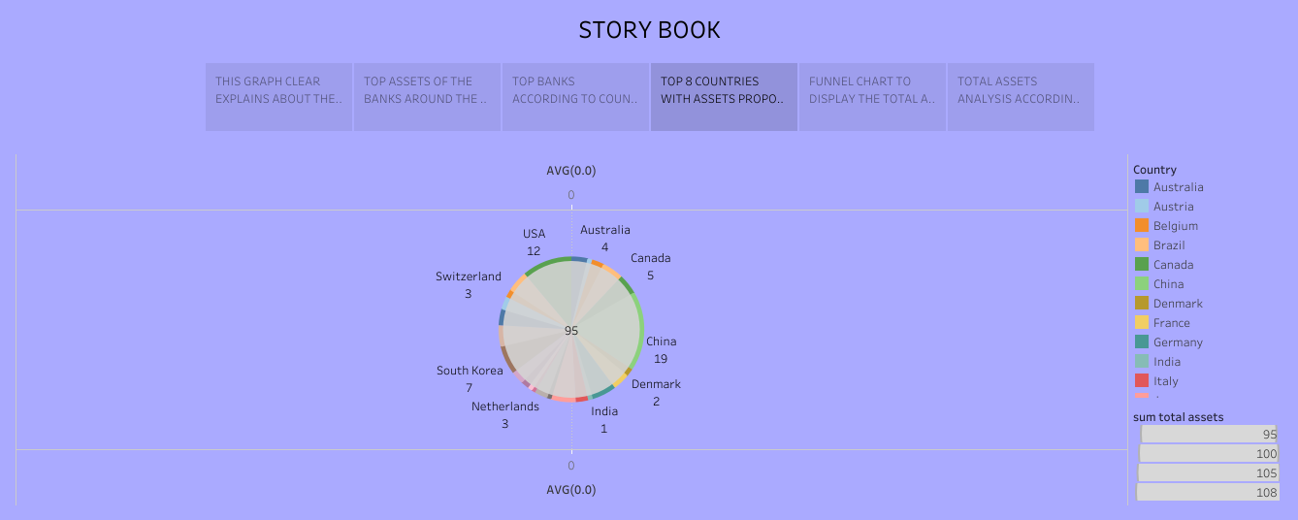

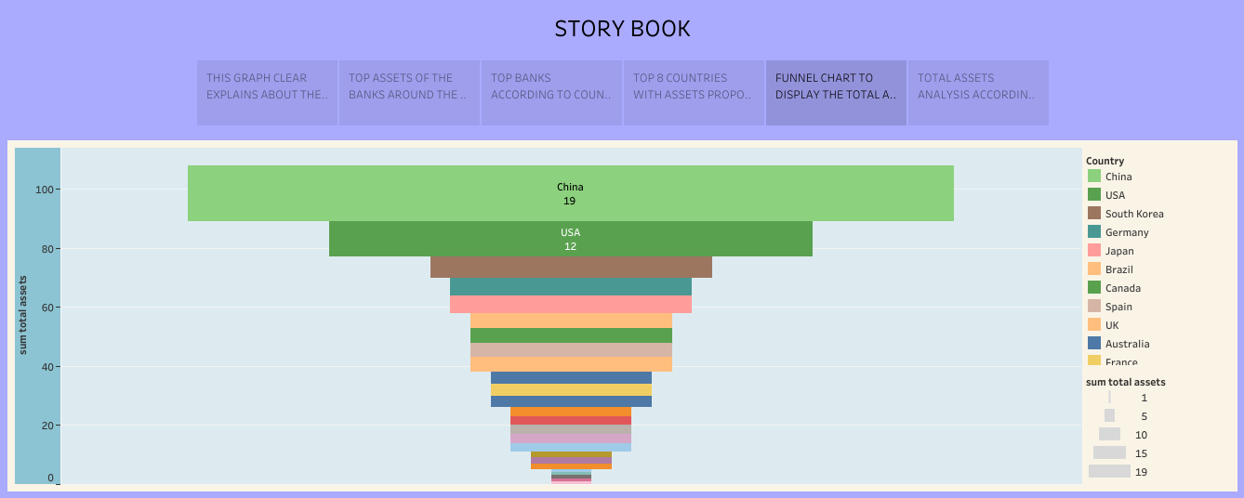

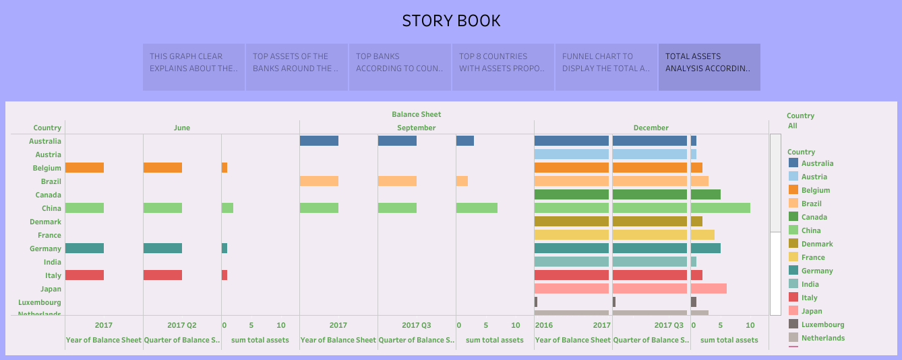

ADVANTAGES:

* It helps to measure the economic trends and the future probability.
* The most important benefit if financial statement analysis is that it provides an idea to the investors their funds in a particular company.
* It is helpful in analysis the asset management, liquidity, debt management, market value, the financial performance of the various departments, and profitability of the business parts.

DISADVANTAGES:

* The real problem started in Banks exploited the forbearance window to restructure loans even for unviable entities, thereby window-dressing their books.
* The hidden bad assets in the bank book and led to an under-estimation of the capital requirements.
* The inflated profits were then used by banks to pay increased dividends to shareholders, including the government in the case of public sector banks.

APPLICATIONS:

Financial performance analysis includes analysis and interpretation of financial statements in such a way that it undertakes a full diagnosis of the profitability and financial soundness of the business. The financial analyst program provides vital methodologies of financial analysis.

## CONCLUSION:

In conclusion, this project analyzes the function of financial statements for a bank to use it as operation guideline and explain how useful for a bank to invest and avoid risks. Different parts of financial statement contribute unique use value for bank. Specifically, to understand the solvency, assets in a bank can analyze cash flow statement to check the operation position and profit of a bank.

FUTURE SCOPE:

By this project of data analytics in the Insights of banks, it is a comprehensive analysis, so it is should be useful for the future generations to be aware about the financial performance and the safety measures should be taken by the related banks.

APPENDIX:

Source code:

file:///C:/Users/ELCOT/Downloads/gracelin/A%20Comprehensive%20Analysis%20of%20Financial%20Performance_%20Insights%20from%20a%20Leading%20Banks/index.html#portfolio